**Name:- Piyush Kulbhushan Adake**

**SRN:- 31231586**

**Class:- MCA**

**Subject:- Object Oriented Software Engineering**

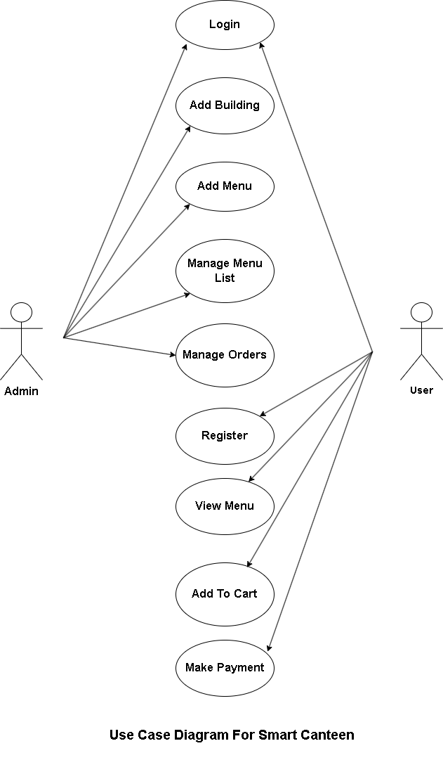

* **Use Case Diagram For Smart Canteen**